SIMATS ENGINEERING (SAVEETHA SCHOOL OF ENGINEERING)
Department of Computer Science and Engineering ASSESSMENT TOOL 3 – CASE STUDY
Course Code: | CSA06 |  | Course Title: | Design and Analysis of Algorithms
CO Assessed: | CO3: Articulation (BL4, BL5) |  | Assessment: | Assessment Tool 3 – Case Study
Weightage: | 20% of CIA |  | Total Marks: | 100 (2 Questions × 50 Marks)
CO3 Statement: | Design Divide and Conquer algorithms for Merge Sort, Quick Sort, Binary Search and Matrix Multiplication
Student Name: | Lella Thannveer Reddy |  | Reg. No.: | 192524293
Section / Batch: | Slot - A |  | Date: | 17-08-2026
Instructions to Students
- Answer both questions. Each question carries 50 Marks. Total: 100 Marks.
- Carefully analyze the given case study questions.
- Explain in detail with sample code if needed.
- Clearly identifies all key issues, in-depth analysis, Innovative, feasible solutions with strong justification
Question Type |  | Description |  |  | Questions | Total Marks
Case Study |  | Focus on Design Divide and Conquer algorithms: Merge Sort, Quick Sort,  Binary Search and Matrix  Multiplication |  |  | Q1 – Q2 | 100

SECTION A – CASE STUDY

CSA06 – DESIGN AND ANALYSIS OF ALGORITHMS
CO3 – Divide and Conquer
CASE STUDY ASSIGNMENT
Topics: Merge Sort, Quick Sort, Binary Search, Matrix Multiplication

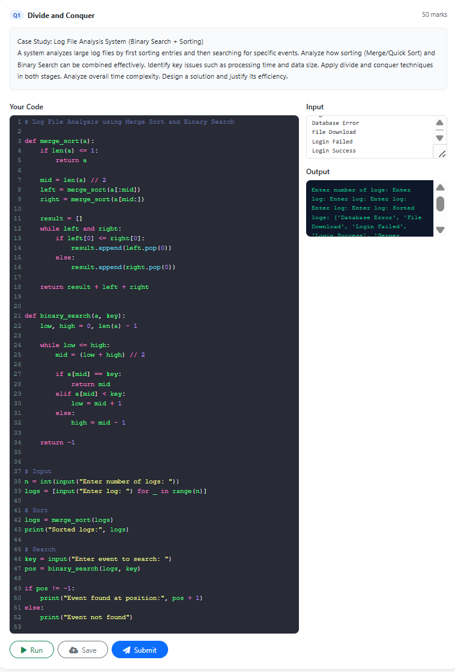
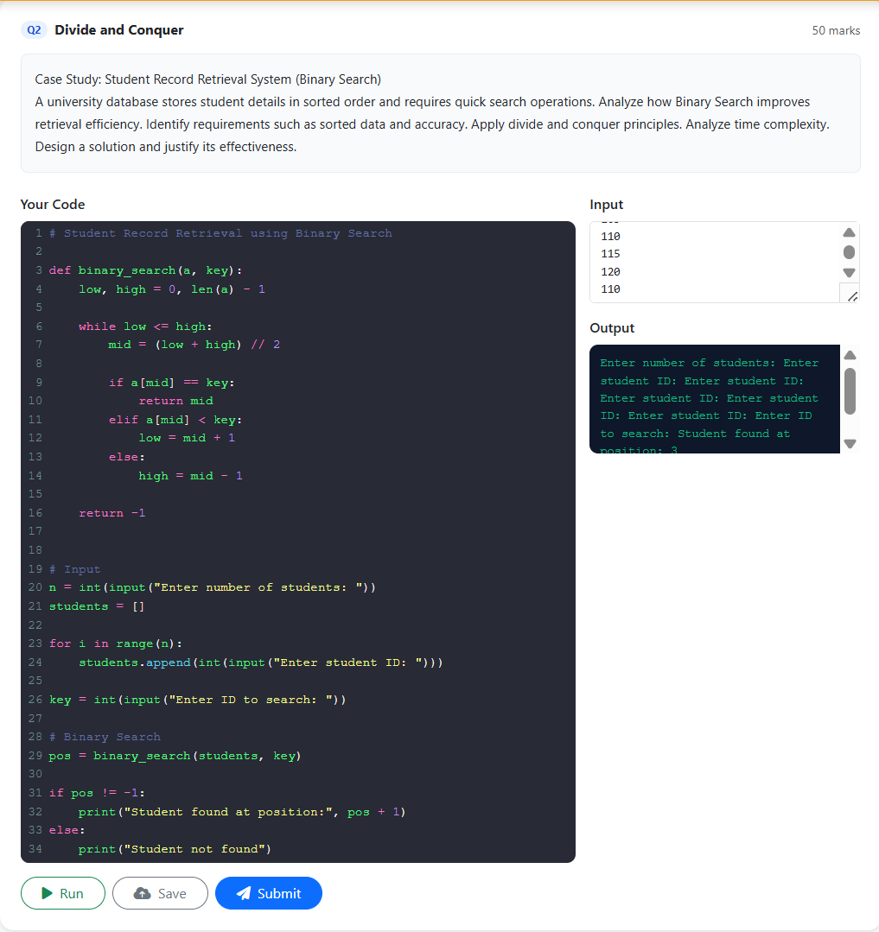

Code of Conduct
Lella Thannveer Reddy/192524293 (Name / Reg No) certify that this submission is my original work and that I have adhered to the guidelines specified for this assessment. I understand that any violation of academic integrity rules will result in disciplinary action.
Signature of the Student: 

RUBRICS FOR CALCULATION

Case Study
Criteria | Weightage | Level 4 –  Exemplary | Level 3 – Proficient | Level 2 –  Developing | Level 1 – Beginning
Understanding of Case | 25 | Thorough understanding; clearly  identifies all  key issues | Good understanding with most issues identified | Basic understanding;  some issues missed | Poor understanding;  problem not  identified correctly
Application of Concepts | 25 | Effectively applies relevant concepts to  analyze the case deeply | Applies appropriate  concepts with  minor gaps | Limited application of concepts | Fails to apply relevant concepts
Analysis | 20 | In-depth analysis with | Good analysis with logical | Basic analysis with limited | Weak or no analysis; lacks
 |  | strong  reasoning and insights | reasoning | depth | reasoning
Solution Design | 20 | Innovative, feasible  solutions with strong justification | Logical solutions with adequate justification | Basic solutions with weak justification | Incorrect or no solution provided
Clarity | 10 | Clear, wellstructured, and easy to understand | Organized and understandable  presentation | Limited clarity and structure | Poor clarity; difficult to understand
Mark Evaluation:

Case Study | Understanding of case  (25) | Applications of concepts  (25) |  | Analysis  (20) | Solution  Design  (20) |  | Clarity  (10) | Total  Marks  (Each -  50)
Q1
Q2
 |  |  |  |  | Overall Total (100)
Faculty In-charge |  |  | Course Coordinator |  |  | Head of Department
Name: __________________  Signature: _______________ |  |  | Signature: _______________ |  |  | Signature: _______________
Date: ___________________ |  |  | Date: ___________________ |  |  | Date: ___________________

